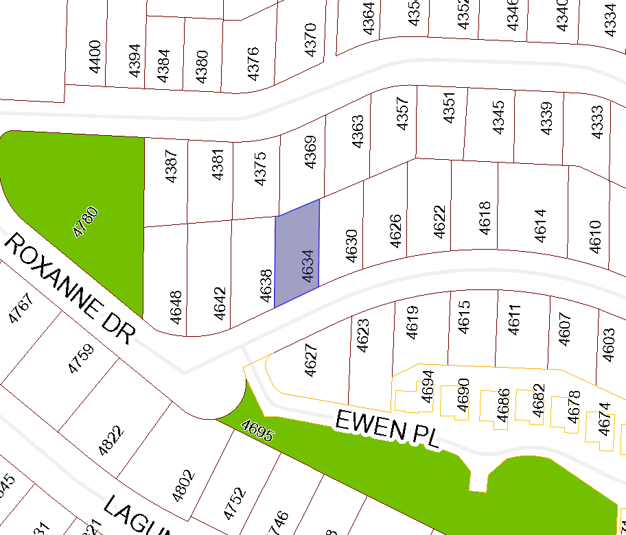
BOARD OF VARIANCE APPLICATION BOV00675

LOCATION MAP

CIVIC: 4634 SHERIDAN RIDGE ROAD

LEGAL: LOT 9, DISTRICT LOT 55, WELLINGTON DISTRICT, PLAN VIP84780

